OOG Spring Meeting, London 11th-13th April 2019
St Bartholomew’s Hospital, West Smithfield London EC1A 7BE
Host Victoria Cohen

First Name __________________________Surname_____________________

Institution ________________________________________________________

Address:_________________________________________________________

Country______________________ Zip/ Post code________________________

Email____________________________________________________________

Abstract Deadline is January 31st. 2019

Registration Fees
OOG Members_______________________________________________295 Euros
OOG Non-Members___________________________________________325 Euros

Accompanying Persons________________________________________150 Euros
(includes one ticket Open-Top Double-Decker Bus tour of London, to Gala dinner ticket and London Pub experience)

Advanced Registration deadline 4th April 2019

Payment

All OOG members should kindly pay their annual dues of 30 euros prior to registering.Payments can be made to the following account:

BANK; Caisse De Credit Mutuel, Bayeux
Ban Account ID: 10278 02138 00020085001 44
IBAN: FR76 1027 8021 3800 0200 8500 144
BIC : CMCIFR2A
Account Holder: GROUPE D’ONCOLOGIE OCULAIRE, 8 Rue Des Moulins 14250 Audrieu
Please do not forget to bring a proof of your payment to the registration desk at the meeting. The option to register and pay onsite will be available, but it would it be much preferred if online banking could be used.

Fees include

- Admission toYIN (Young Investigators Network) Meeting Thursday 11th April 3pm till 4.30pm

- High Tea in the Great Hall, St Bartholomew’s Hospital Thursday 11th April

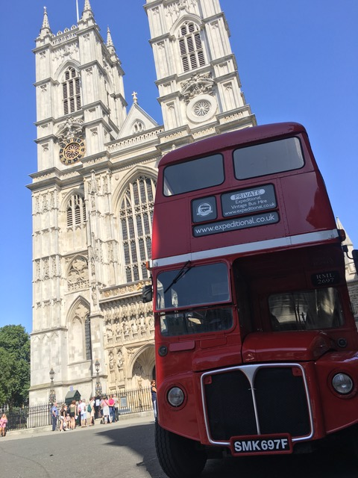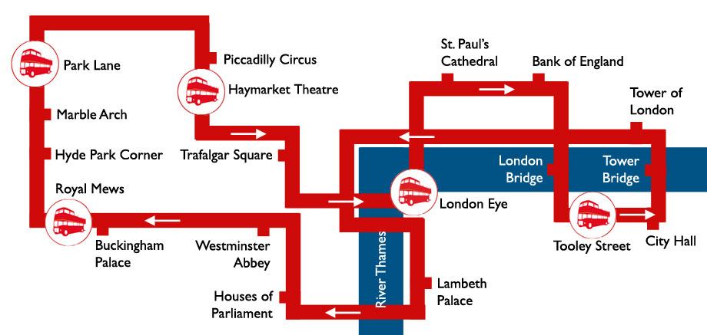

- Tour of Central London on an Open-Top Double Decker London Bus with guide Thursday 11th April

- London Pub experience Thursday Evening 11th April

- Admission to OOG ( Ophthalmic Oncology Group) Meeting Friday 12th-Sarturday 13th April

- Full Catering throughout the meeting

- Drinks Reception and Gala Dinner in the Great Hall of St Bartholomew’s Hospital, West Smithfield London Friday evening 12th April.

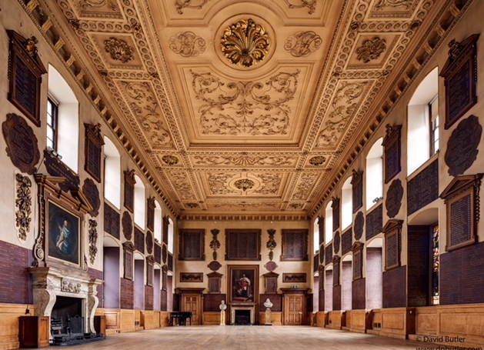

Event Reservation

Your Name __________________________________________________________

Please circle your preferences and indicate number of accompanying persons

Thursday 11th April Yes No
YIN Meeting

Thursday 11th April Yes No
High Tea

Thursday 11th April Yes No
Open Top London Double Decker Bus Guided Tour

Number of Accompanying Persons _________

Thursday 11th April Yes No
English Pub Experience

Number of Accompanying Persons _________

Friday 12th April Yes No
Drink reception and Gala Dinner Great Hall

Number of Accompanying Persons _________

